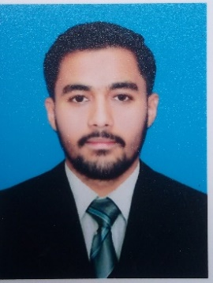 Biodata Form

Session 2023-1st Semester

Department of Computer Science

University of Engineering and Technology

1. Name: Muhammad Abubakar

Tick one option from below

1. Gender: Male Female

dhjhjwjhjdchjjcdbhbjbhjcjhjhdsvhcjvjhbdjhchb

1. Date of Birth:02/09/2004
2. Residence: Chak no.115 S/B Sargodha
3. City: Sargodha
4. Mobile:03270216115
5. Email:itsabubakar103@gmail.com
6. Hobby: Gardening
7. Favourite Movie: none